Special Types of Numbers-Answers
Key Stage 3: 2003 Paper 1 Level 3-5
1.
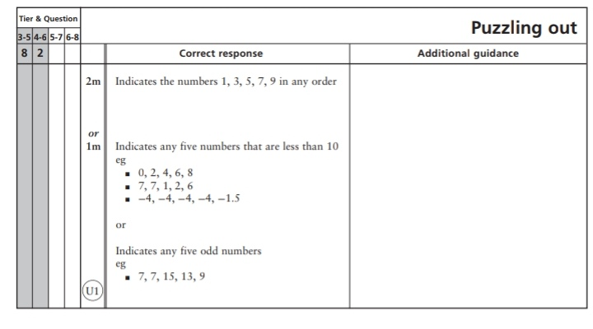
Key Stage 3: 2003 Paper 1 Level 4-6
2.
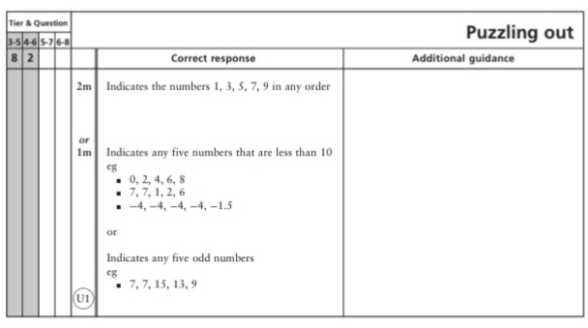
Key Stage 3: 2004 Paper 2 Level 3-5
3.
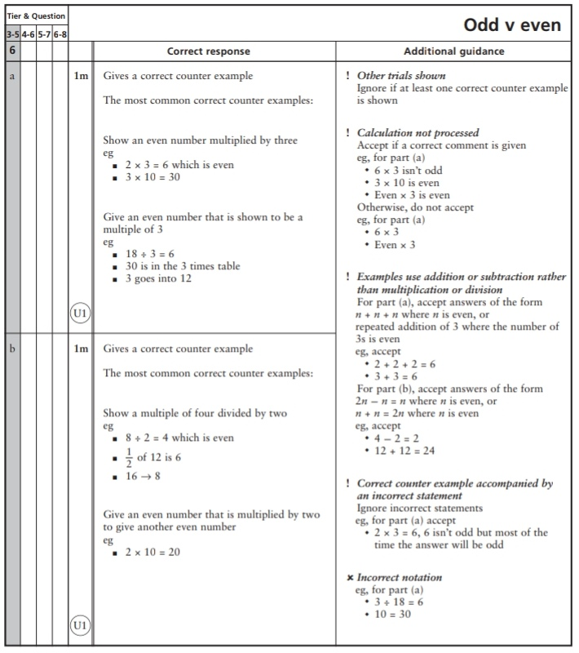
4.
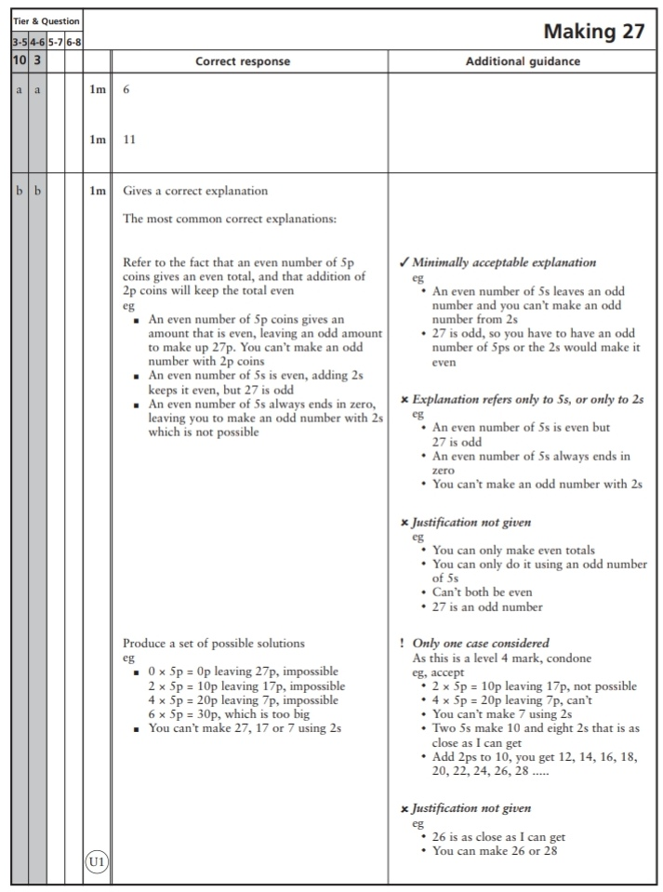

Key Stage 3: 2004 Paper 2 Level 4-6
5.
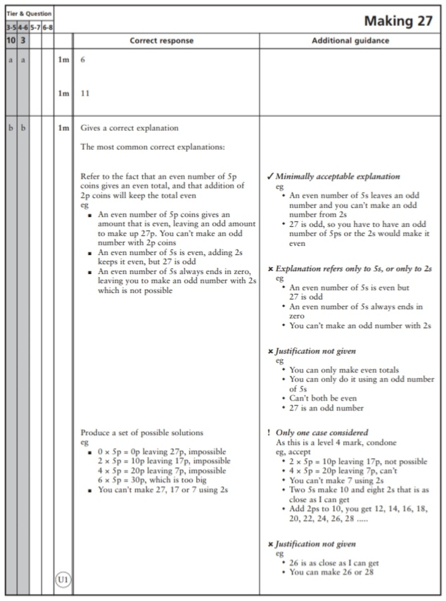
Key Stage 3: 2006 Paper 1 Level 3-5
6.
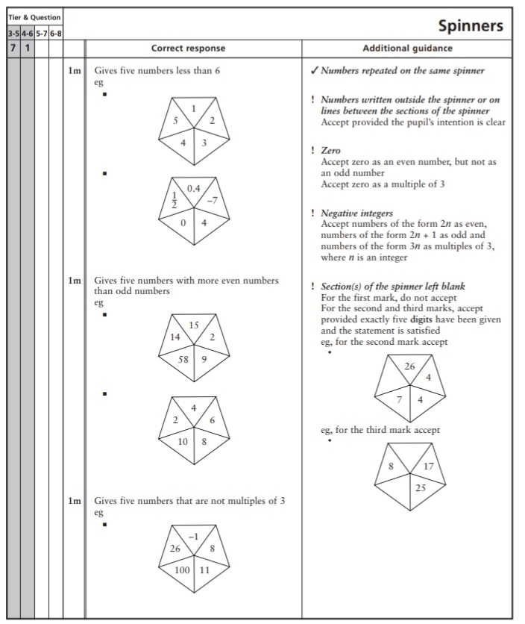
Key Stage 3: 2006 Paper 1 Level 4-6
7.
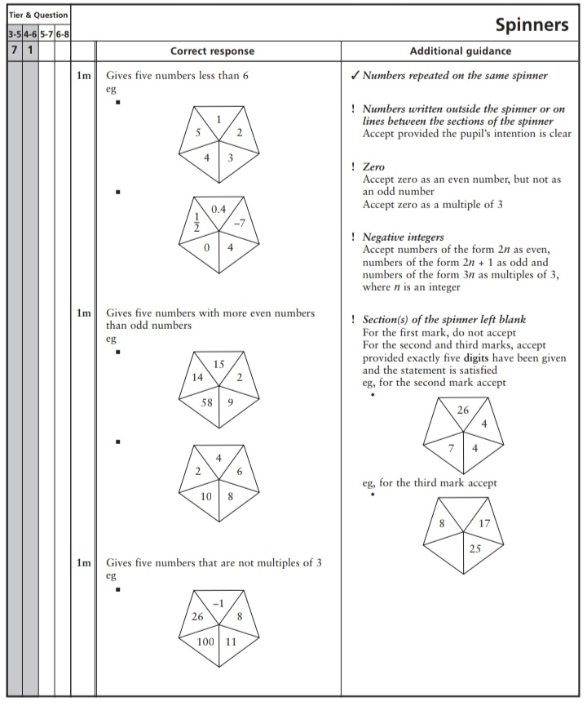
Key Stage 3: 2008 Paper 1 Level 3-5
8
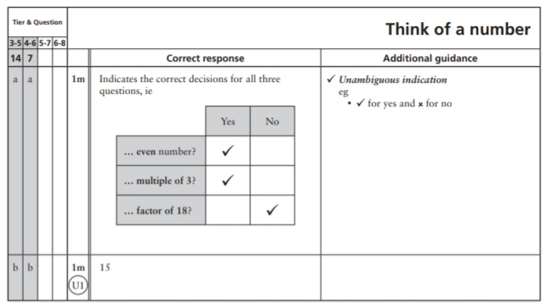
Key Stage 3: 2008 Paper 2 Level 3-5
9.
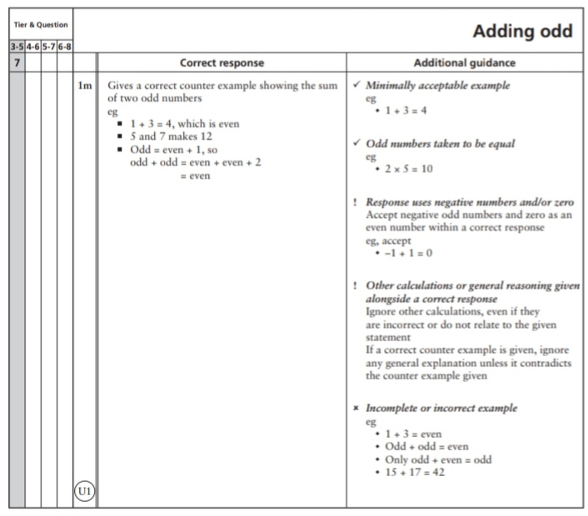
10.
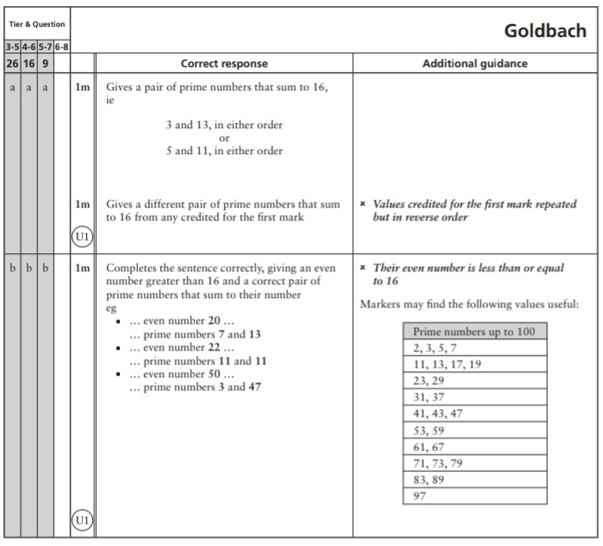
Key Stage 3: 2008 Paper 1 Level 4-6
11.
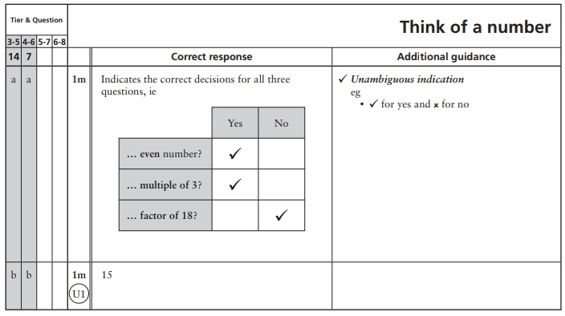
Key Stage 3: 2008 Paper 2 Level 4-6
12.
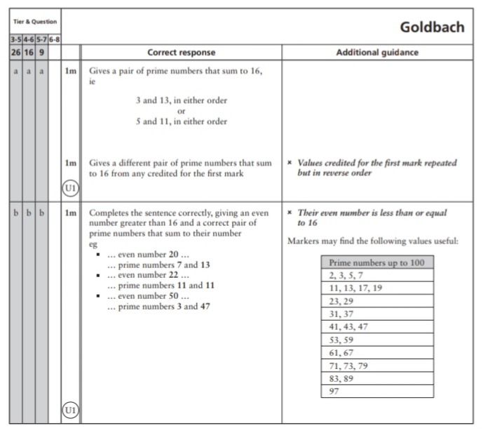
Key Stage 3: 2009 Paper 2 Level 3-5
13.
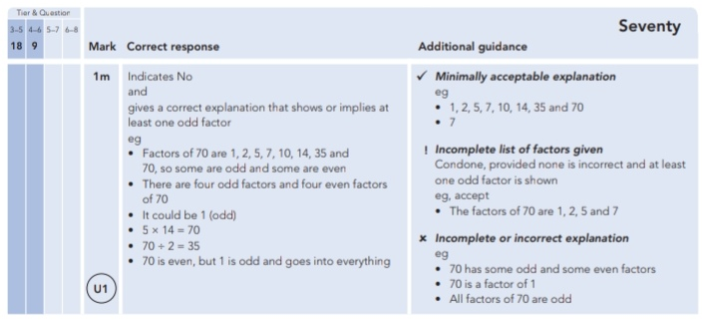
Key Stage 3: 2009 Paper 1 Level 4-6
14.
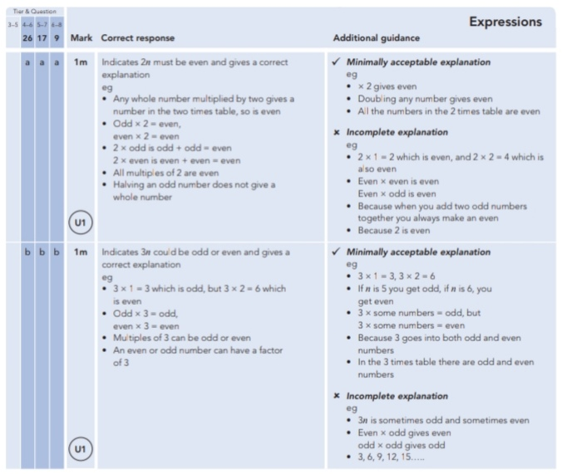
Key Stage 3: 2009 Paper 2 Level 4-6
15.

